SHOPIFY AND CAKE

Calling the App API (your app link which sets up access tokens from Shopify) – Calling the App here means link to where your app is (NOT calling Shopify)

Call: http://carrier2.anton.co.za/?shop=mytest-46.myshopify.com

Response:

{"api_permission":{"created_at":null,"id":null,"callback_url":"http:\/\/carrier2.anton.co.za\/carrier\/rate?code=\u0026hmac=1bd371bc2242ef442d3bdeb362ae2fa1655fbb10e3f11bfab931f66fd1f08420\u0026shop=mytest-46.myshopify.com\u0026signature=b402a37c15101a656e22c155e736e53b\u0026timestamp=1428189854","preferences_url":null,"app_url":"http:\/\/carrier2.anton.co.za?hmac=6396cc71d2ed42c37673ee83e9cd2ee4eb119c648275f02aaf5b68310a752a96\u0026shop=mytest-46.myshopify.com\u0026signature=240edb5b1fc721289d144c3e416ef834\u0026timestamp=1428189854","shop_proxy":null,"api_client":{"api_key":"75d76a51f1584bfa01e2049f53e3a87d","api_permissions_count":0,"application_url":"http:\/\/carrier2.anton.co.za","created_at":"2015-03-29T06:51:20-04:00","embedded":false,"handle":null,"id":728871,"kind":"oauth2","mode":"w","number":null,"pos_embedded":false,"support_url":"","title":"CarrierRates","visible":true,"contact_email":"antonfh@gmail.com","banner_url":"\/\/apps.shopify.com\/75d76a51f1584bfa01e2049f53e3a87d\/banner","application_icon":{"to_url":"https:\/\/cdn.shopify.com\/s\/files\/applications\/75d76a51f1584bfa01e2049f53e3a87d.png?1428186129"},"small_application_icon":{"to_url":"https:\/\/cdn.shopify.com\/s\/files\/applications\/75d76a51f1584bfa01e2049f53e3a87d-small.png?1428186129"},"application_developer":{"address1":"Serene Street","affiliate_share_style":"revshare","city":"Pretoria","company_name":"Antonfh","contact_first_name":"Anton","contact_last_name":"Heuschen","country":"za","created_at":"2015-03-25T17:59:08-04:00","email":"antonfh@gmail.com","handle":"antonfh","hst_number":"","id":313789,"im_handle":null,"im_type":null,"latitude":-25.79534,"longitude":28.29192,"name":"Antonfh","partner_manager_email":"ewa.johnson@shopify.com","partnership":"partner","phone":"0735301800","province":"Gauteng","support_email":"antonfh@gmail.com","updated_at":"2015-03-25T17:59:08-04:00","url":"","zip":"0043","application_percent":80.0,"theme_percent":"Default","affiliate_percent":20.0,"billing_account":{"business_id":7164971,"id":7164969,"business":{"company_name":"Antonfh","credit_card_id":null,"id":7164971,"payment_method":"paypal","paypal_account":"antonfh@gmail.com"}}},"api_links":[{"text":"C_CarrierRates","url":"https:\/\/carrier2.anton.co.za\/","location":"checkout details page","icon_path":"https:\/\/cdn.shopify.com\/s\/files\/applications\/75d76a51f1584bfa01e2049f53e3a87d-small.png?1428186129"}],"pos_api_links":[]}},"embedded":false}

This was called with Browser Rest test client, the page should redirect or link to the shop : But from the Rest client app, you get the following link to click:

To:

[**https://mytest-46.myshopify.com/admin/oauth/authorize?client_id=75d76a51f1584bfa01e2049f53e3a87d&scope=read_shipping,write_shipping&redirect_uri=http://carrier2.anton.co.za/carrier/rate**](https://mytest-46.myshopify.com/admin/oauth/authorize?client_id=75d76a51f1584bfa01e2049f53e3a87d&scope=read_shipping,write_shipping&redirect_uri=http://carrier2.anton.co.za/carrier/rate)

with status: **302**

**This link takes us to the Shop page (Not partner or your App page) – but the test Shopify shop you have and the one you defined as the ?shop= in the call :**

http://carrier2.anton.co.za/?**shop=mytest-46.myshopify.com**

The access validation page on the Shop will look something like this:

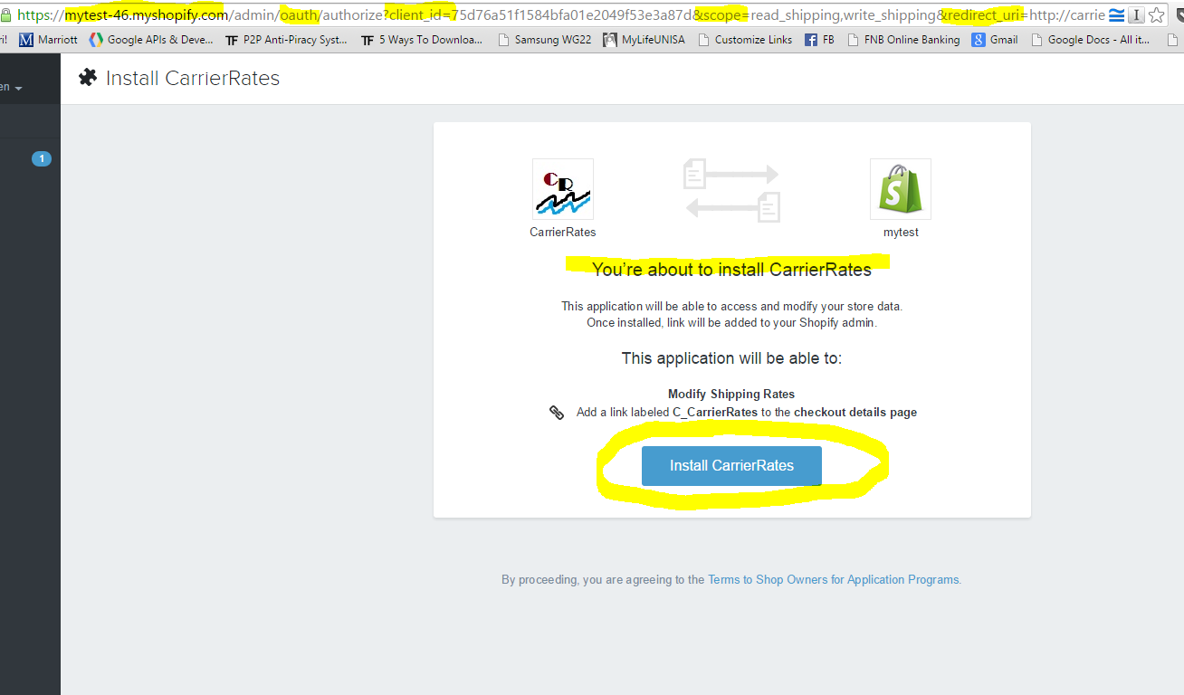

You will then click on the Install button “Install CarrierRates” in this example or Install <Your App name>

Take note, the call-back url you pass will be what is called after clicking the Install button, it is a Get method/request and as such make sure of the following:

1. The call back is an actually REST end point you would want to handle the token/auth request.
2. Do not make the end point such that it cannot find such a route, or there is no such Controller to handle the call back request

**Shopify Token handling:**

One thing to take note of is that Shopify after linking the app and returning the token (if you call it then with the code, Api key and shared secret) – IT WILL ONLY RETUR THE TOKEN ONCE. So if you want to test your API and get no luck with a token, remove the app first from your store, then try again (else it will drive you mad trying to figure out why you are not getting your token)